Addition using SOAP

1.Click on file and select "New"=> "Application" as shown below.

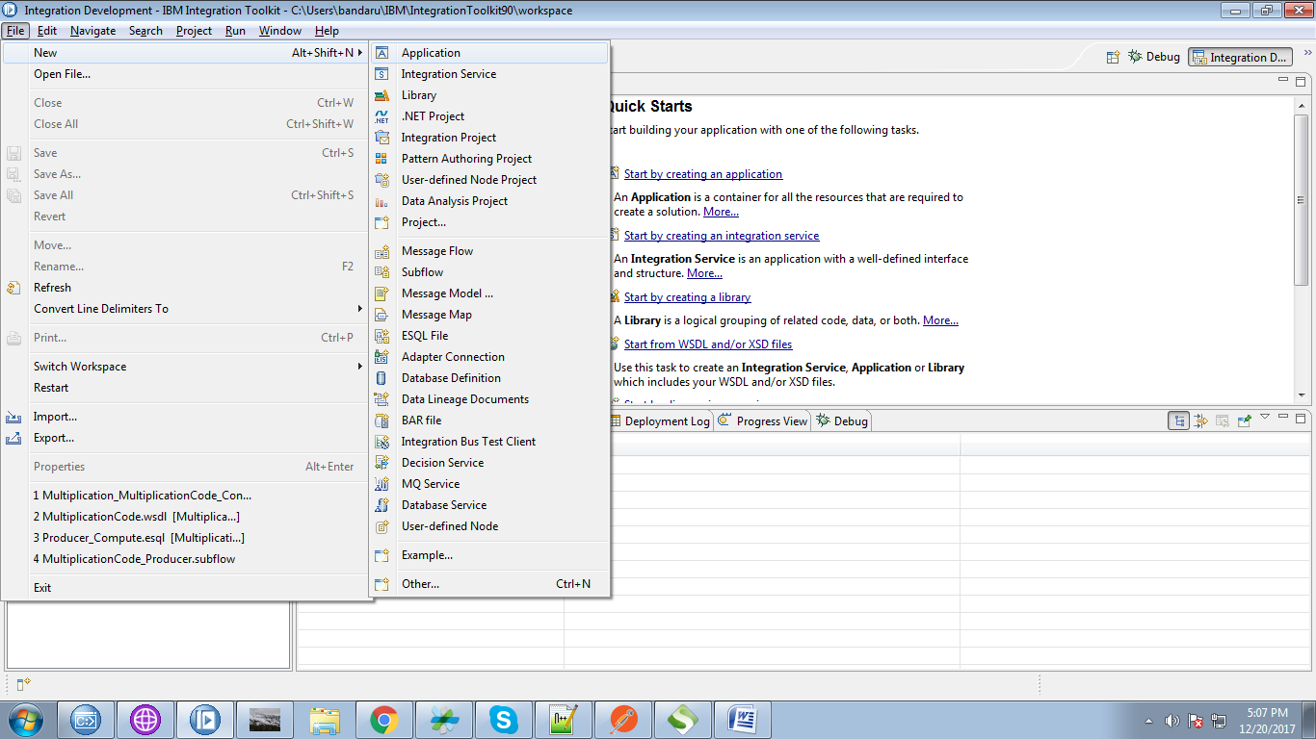

2. Give a name for your application and click "Finish" button.

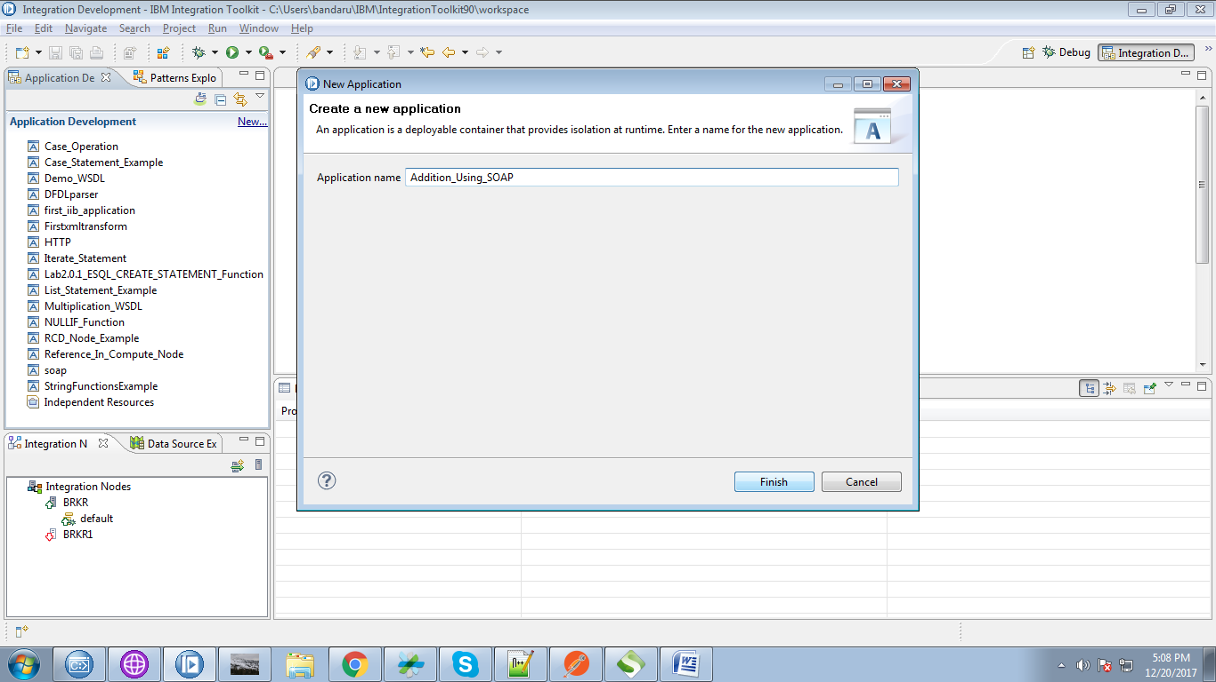

3. Right click on application and select "New"=> "Other".

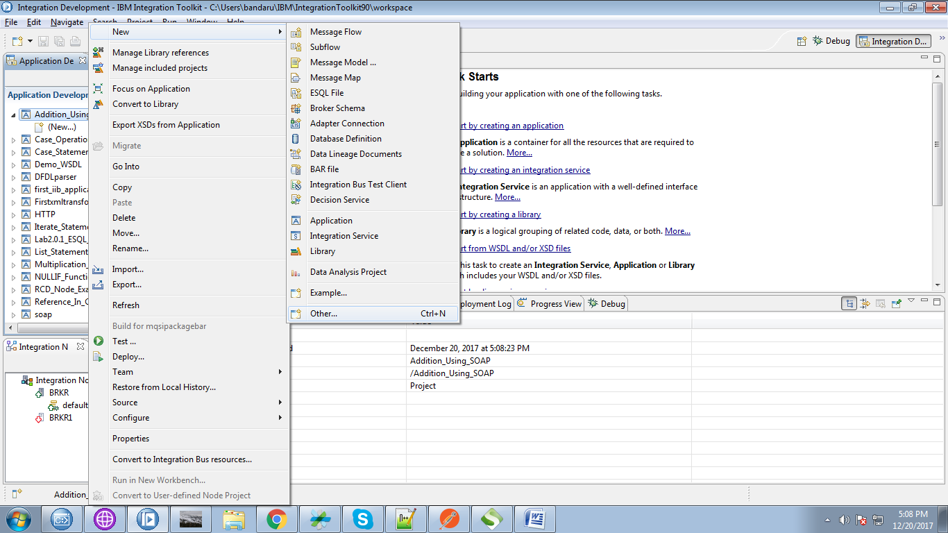

4. From the pop-up select "WSDL" from web services section.

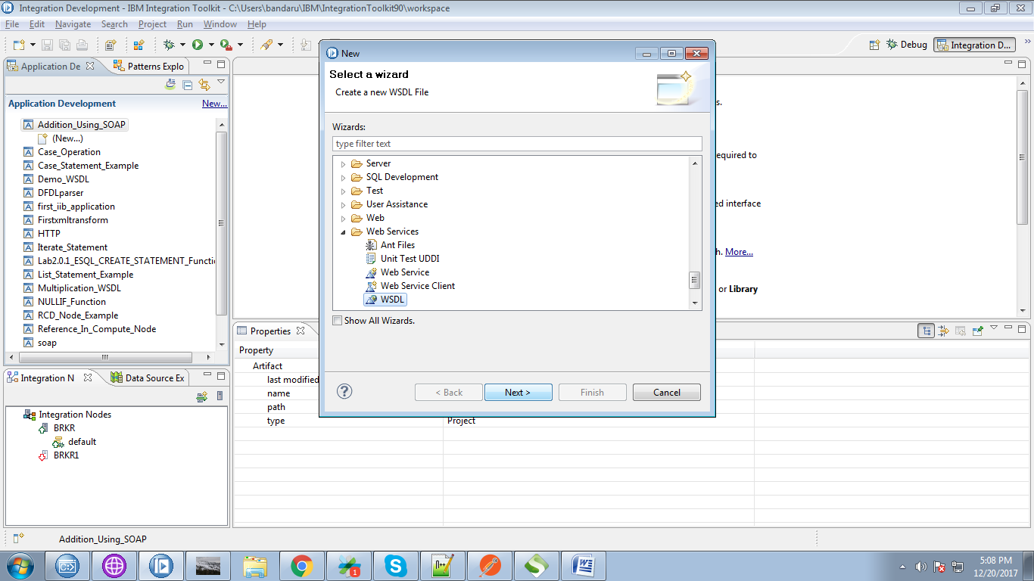

5. Give any name for your file and click on "Next" button.

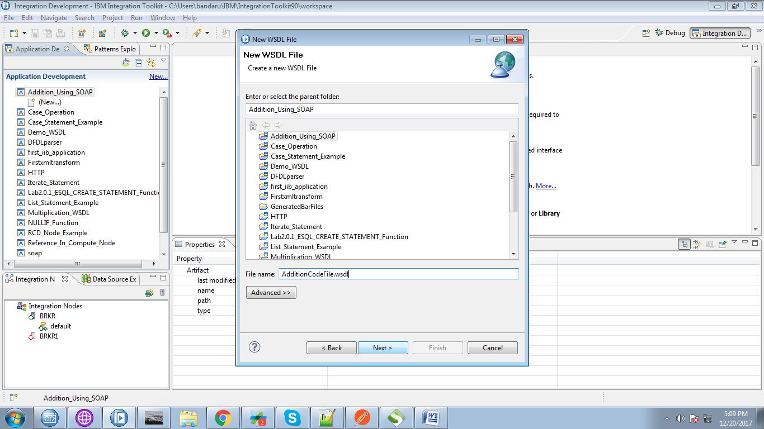

6. Click on "Finish" button.

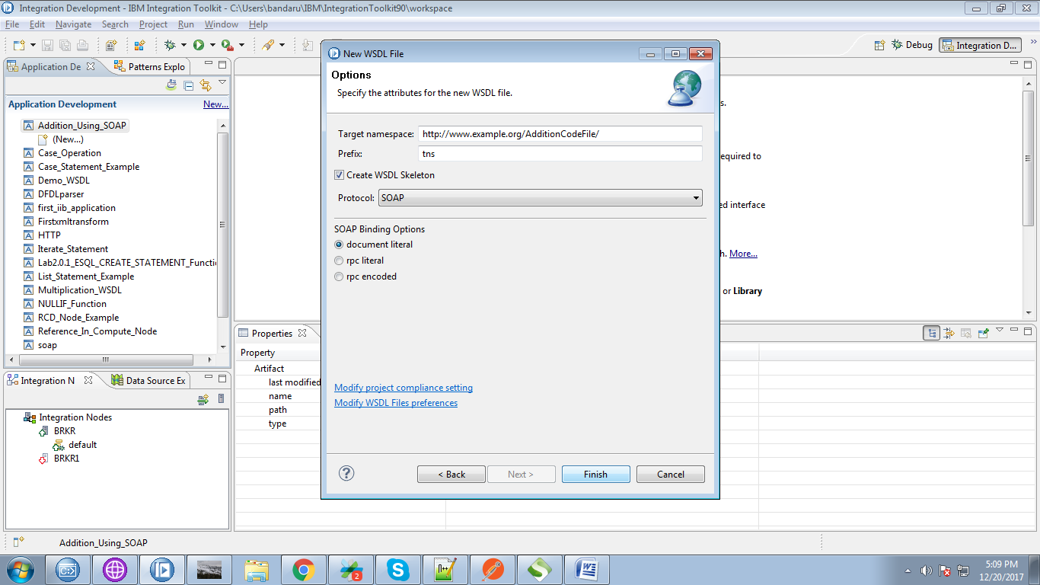

7. WSDL file will be generated as follows.

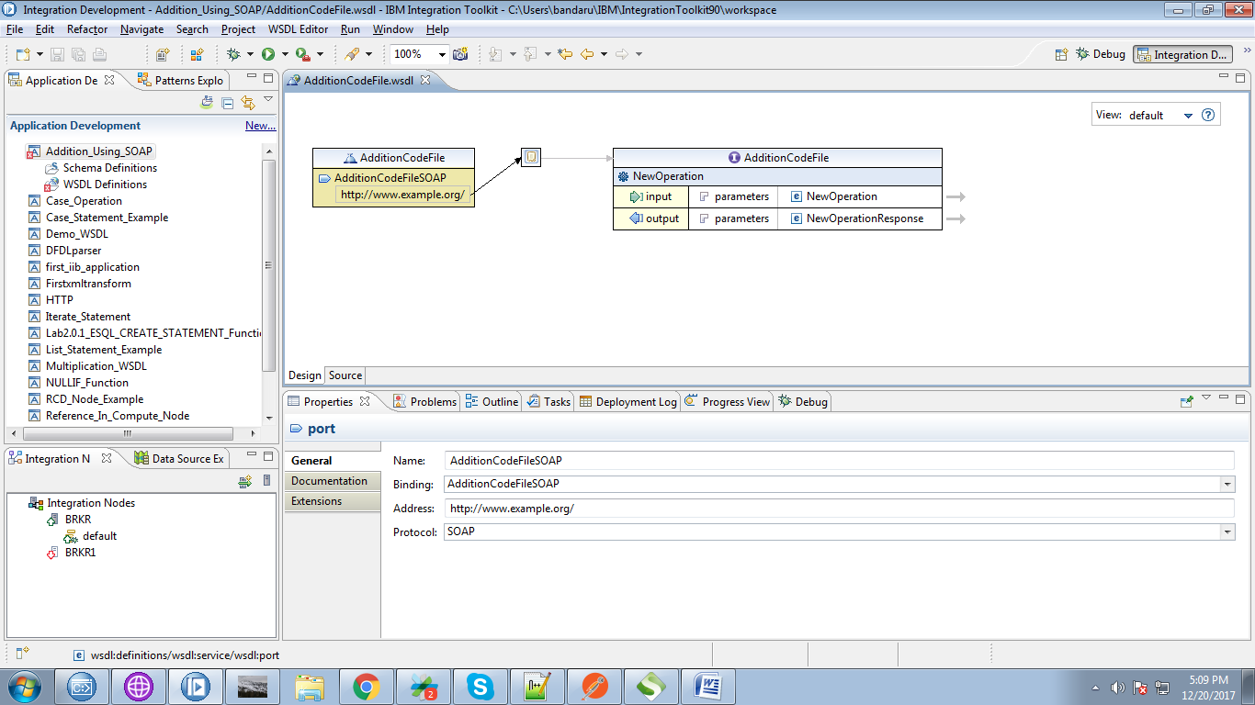

8. Check, on which ports your broker is running, For this, right click on your execution group and select "Properties".

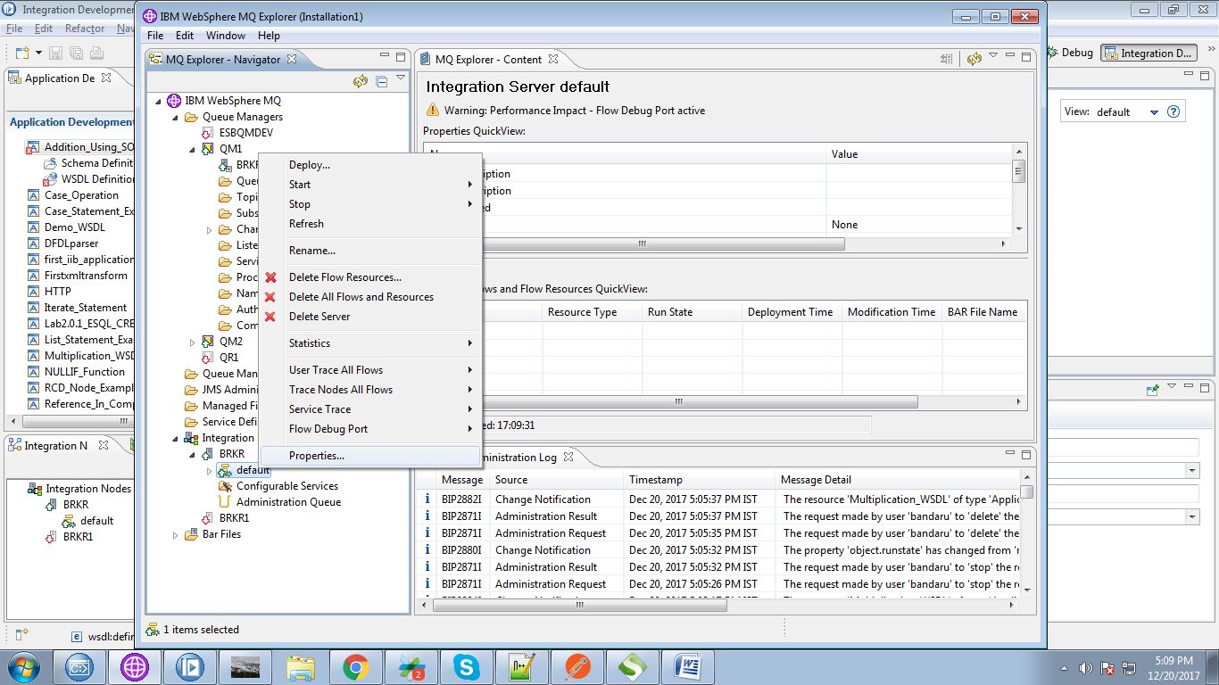

9. Under "Extended" tab, you can see your ports, use HTTP port(as we are not setting any SSL in our application)

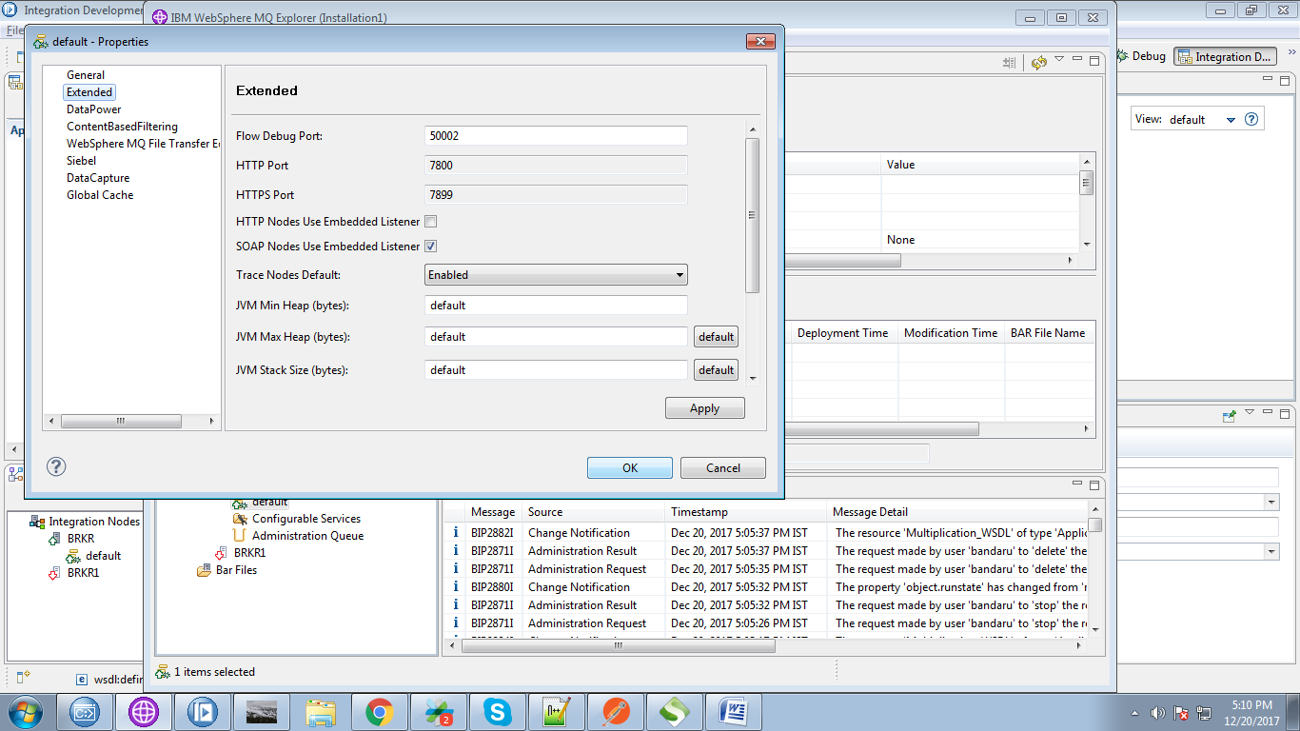

10. Here i used HTTP port here.

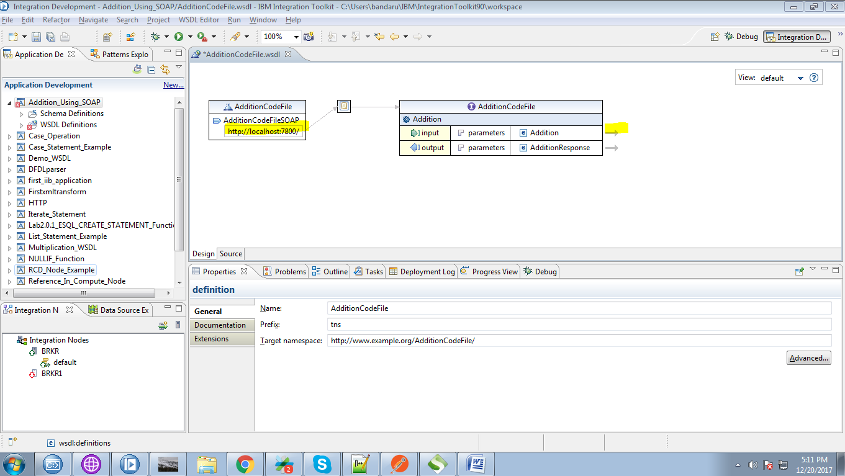

11. You can add additional elements by right clicking on elements tab and selecting "Add Element" as below fig.

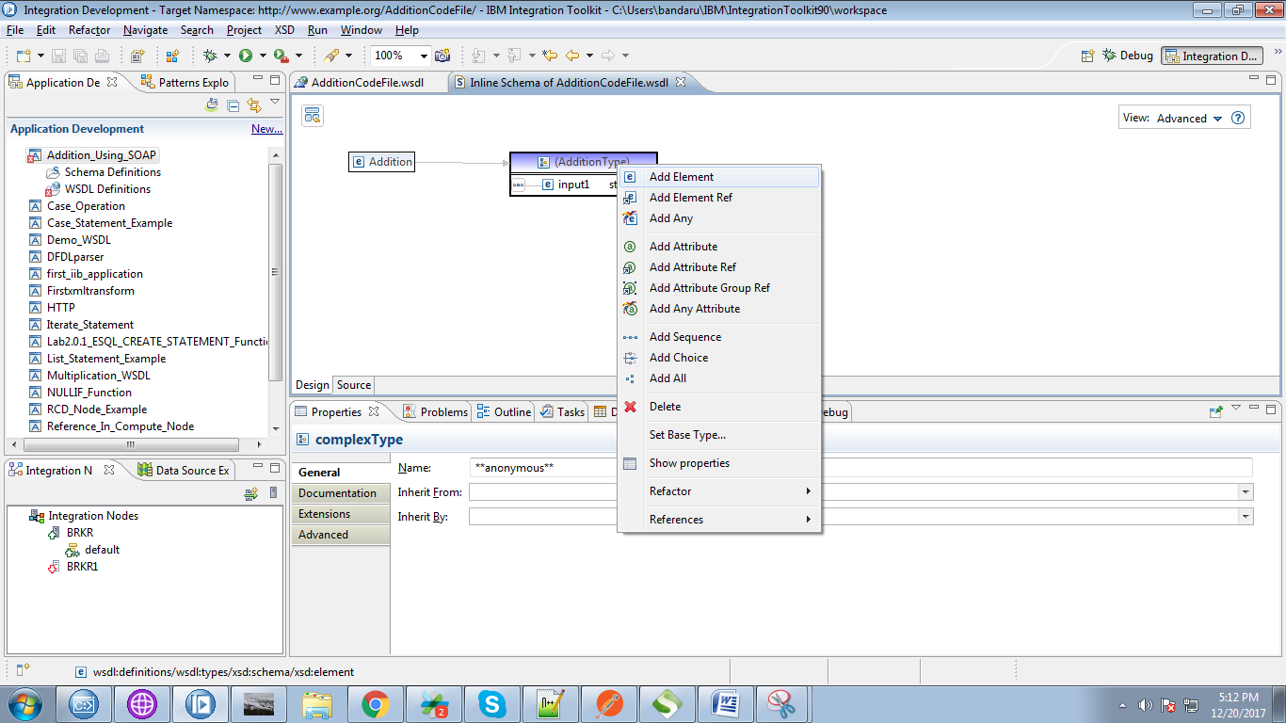

12. Here i added "input2" as another element.

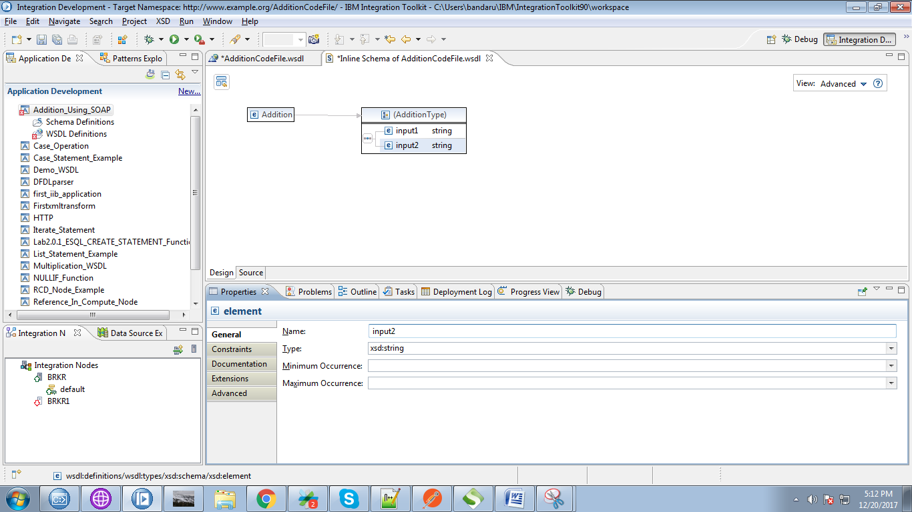

13. Now right click on your application and select "New"=>"Message Model"

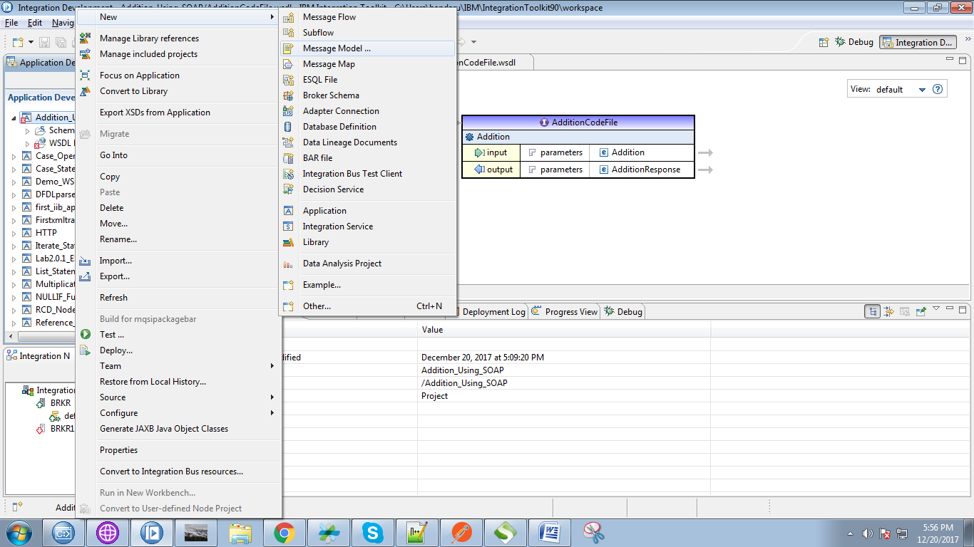

14. Select "SOAP XML" check box and click "Next" button.

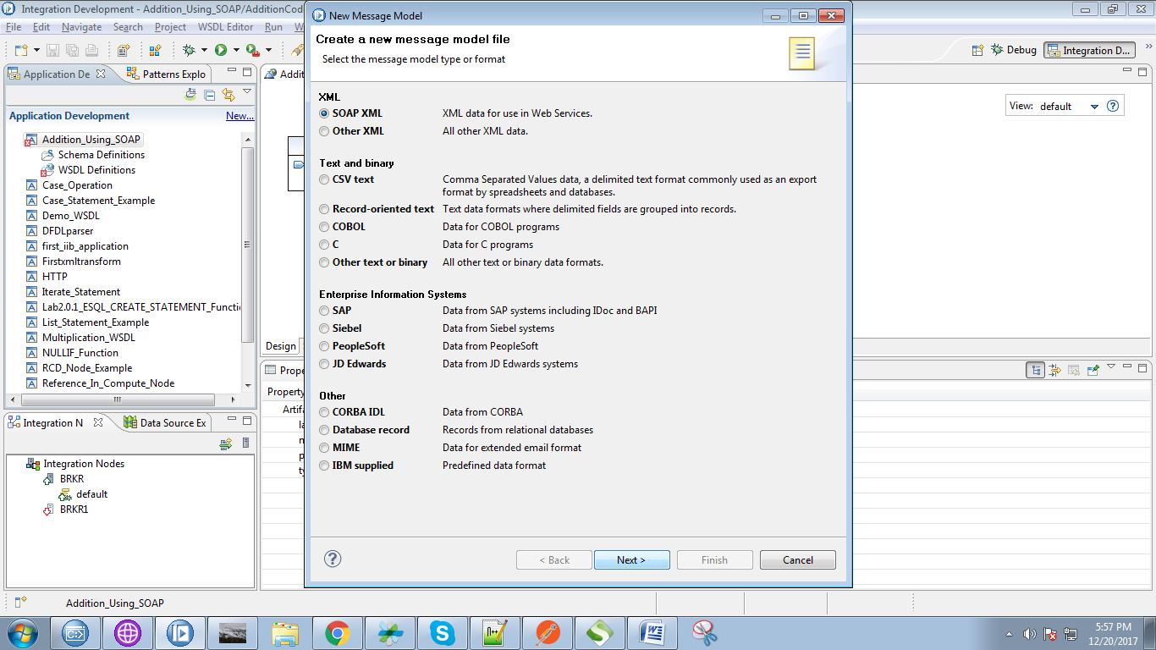

15. Select the "I already have WSDL from my data" and click "Next" button.

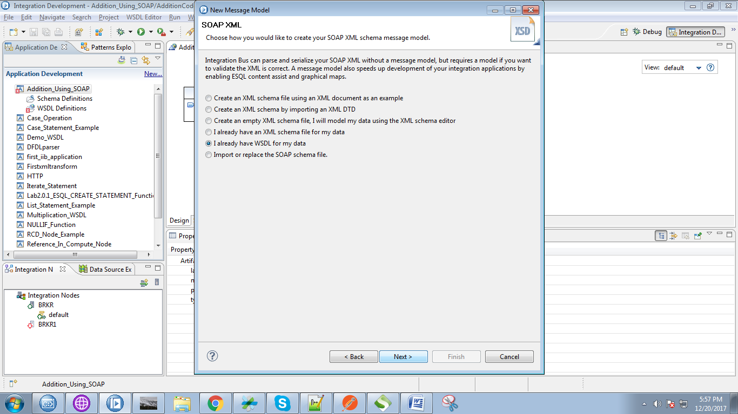

16. Select your WSDL created from the search console and click "Next" button.

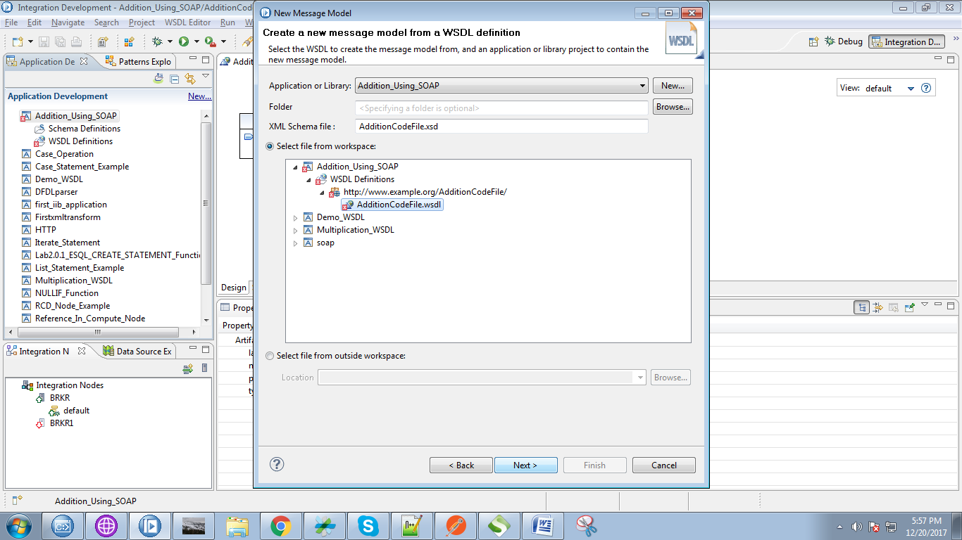

17. Click on "Finish" button finally.

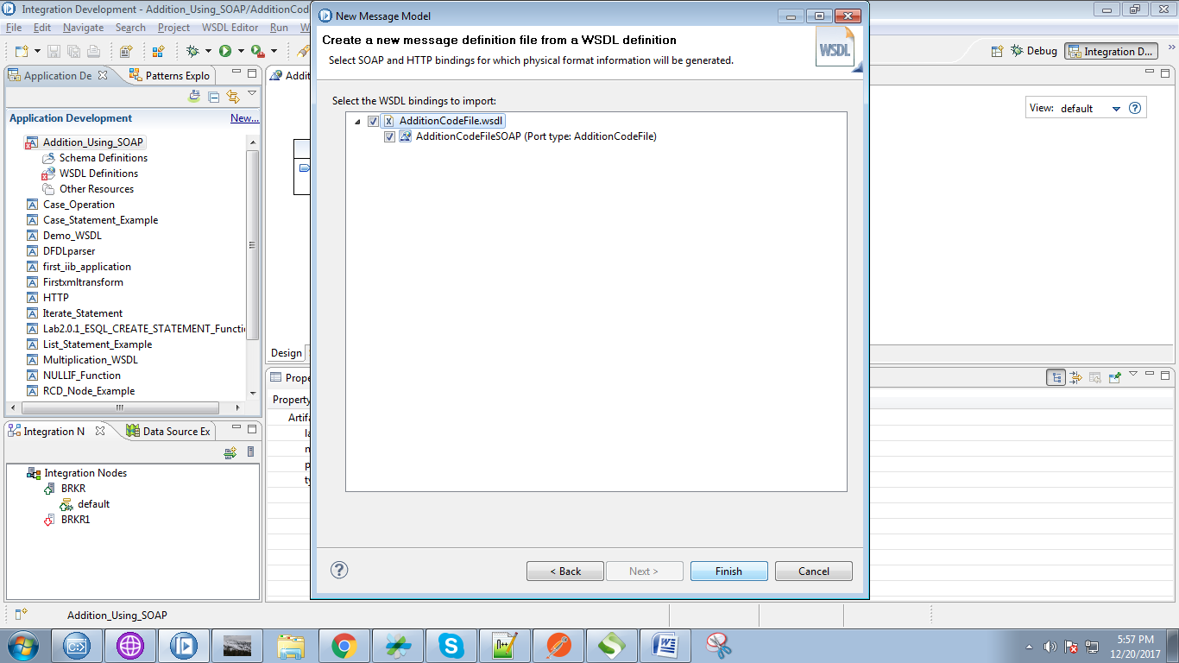

18. Right click on application and select "New"=>"Message Flow".

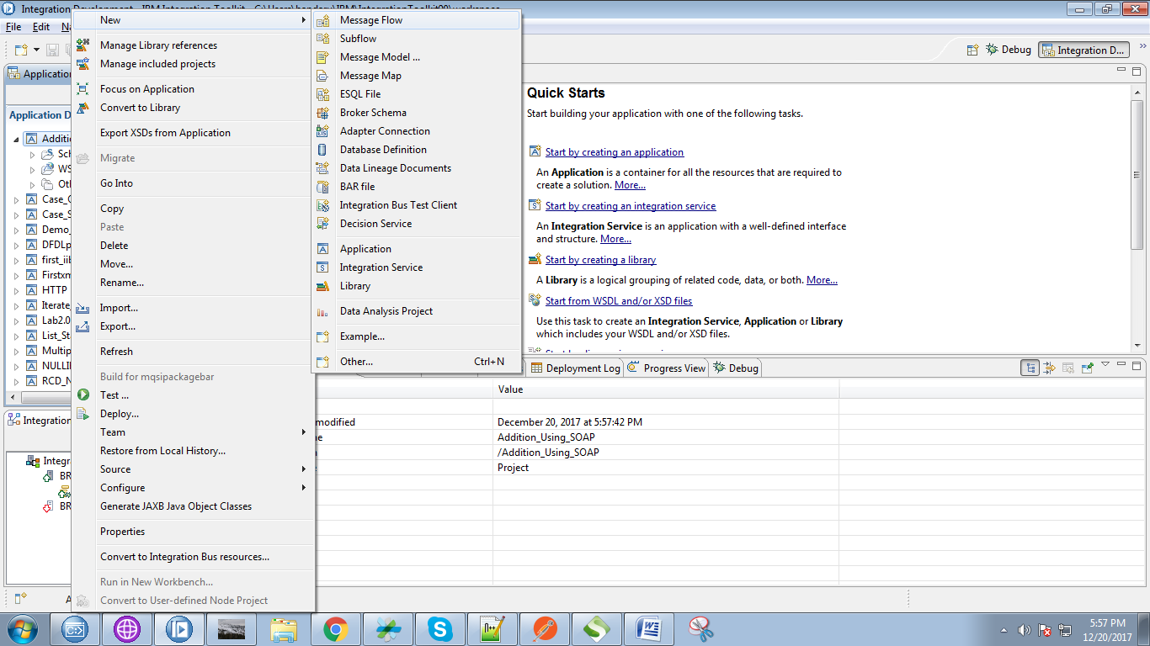

19. Now first we create producer flow,so give the name as producer and click on "Finish" button.

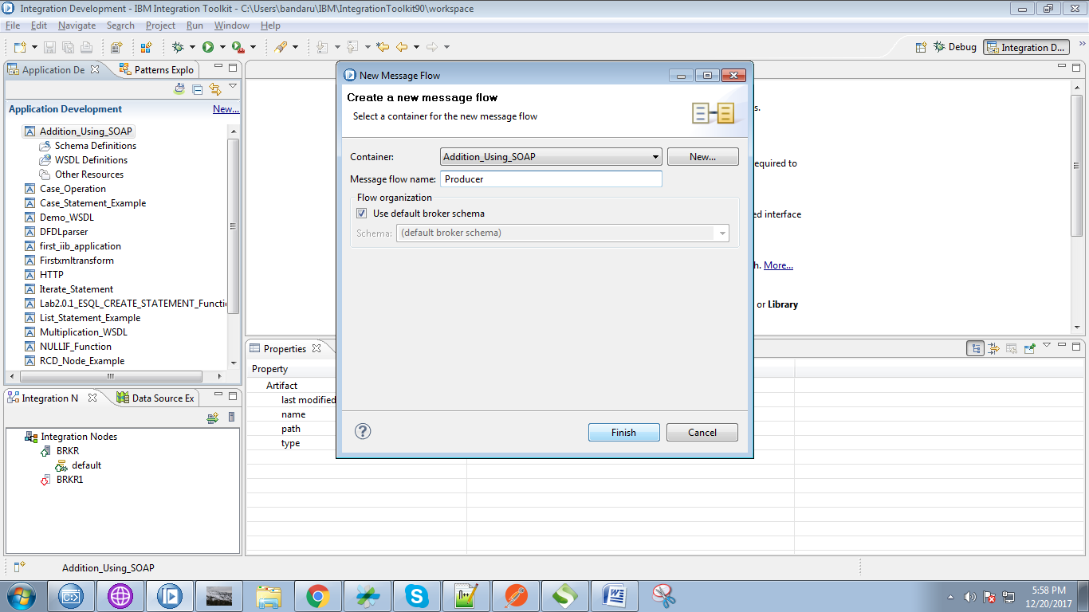

20. Drag your WSDL file on to producer flow, Following pop-up will appears.

* Select "Expose....." option from the top radio buttons.
* Click on "Finish" button.

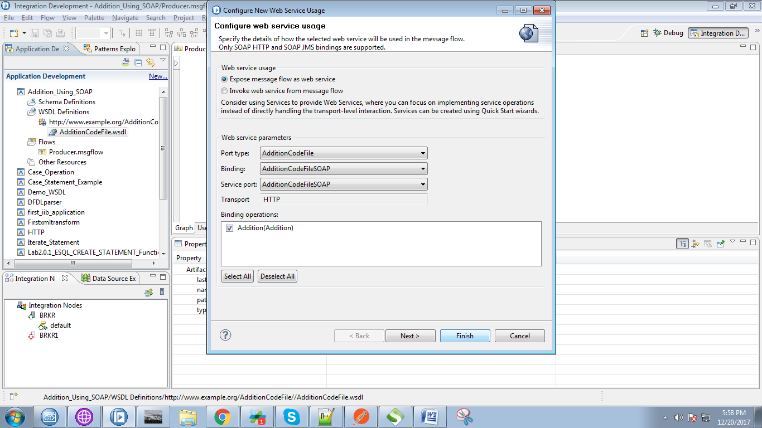

21. Your producer flow will generated as given below. Under SOPA node give path url as "addition"

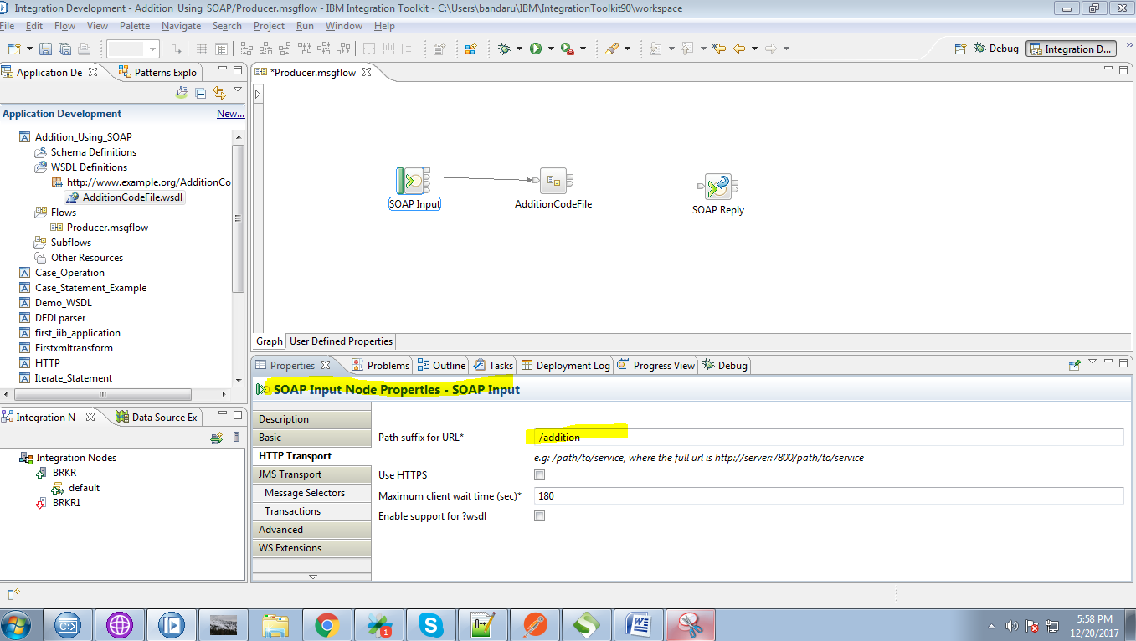

22. Drag the compute node from the "transformation" section.

